KARSON BRADY

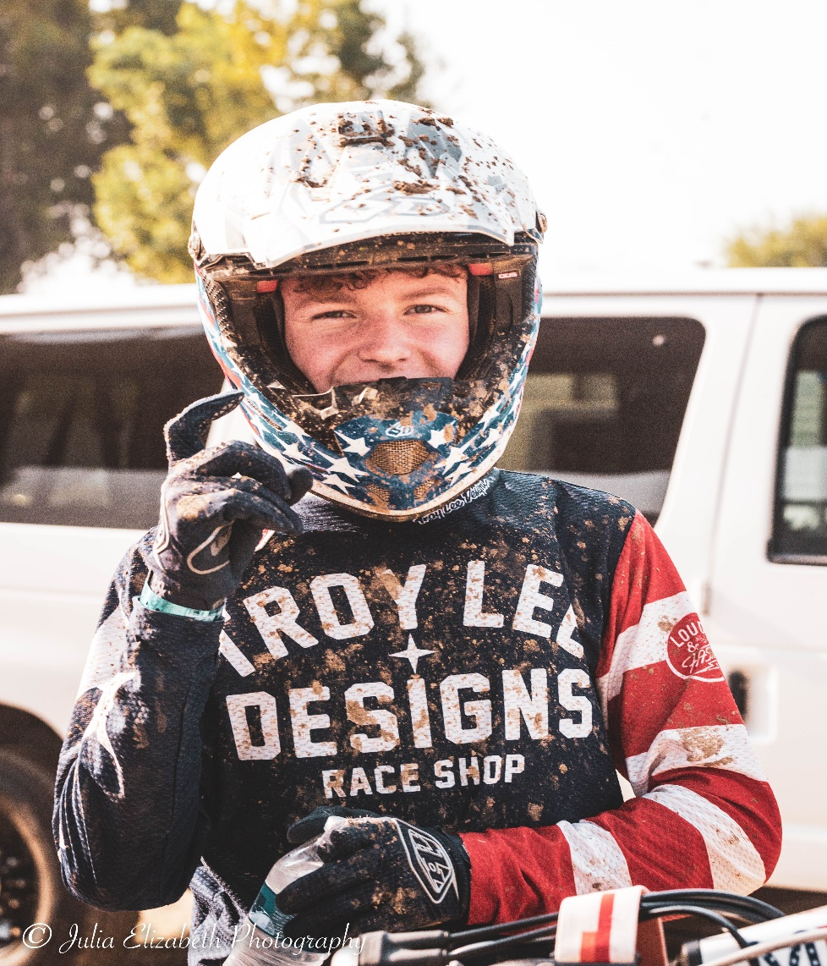

Karson.brady242@gmail.com

Karson Cell: 530-624-9229

Wendy Cell: 530-870-6175

@karson_brady242

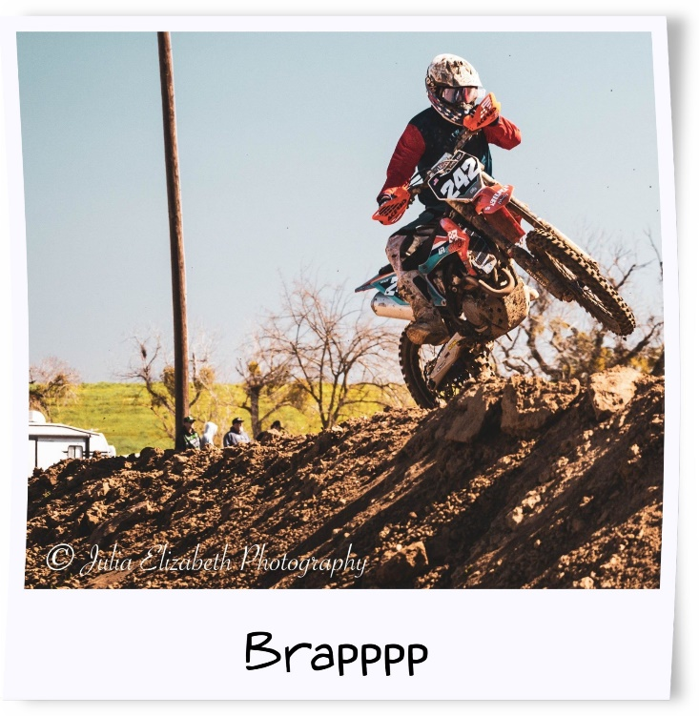ABOUT ME

My name is Karson Brady and I am 14 years old. I started riding when I was 4 years old. My dad bought me a 50cc Suzuki 2 stroke and kept asking me if I was ready to ride it for months until one day I finally said yes. Since then I have been riding every chance I get. I am the youngest of 5 siblings. We all love to ride and go on adventures as a family. Mostly we go to Mexico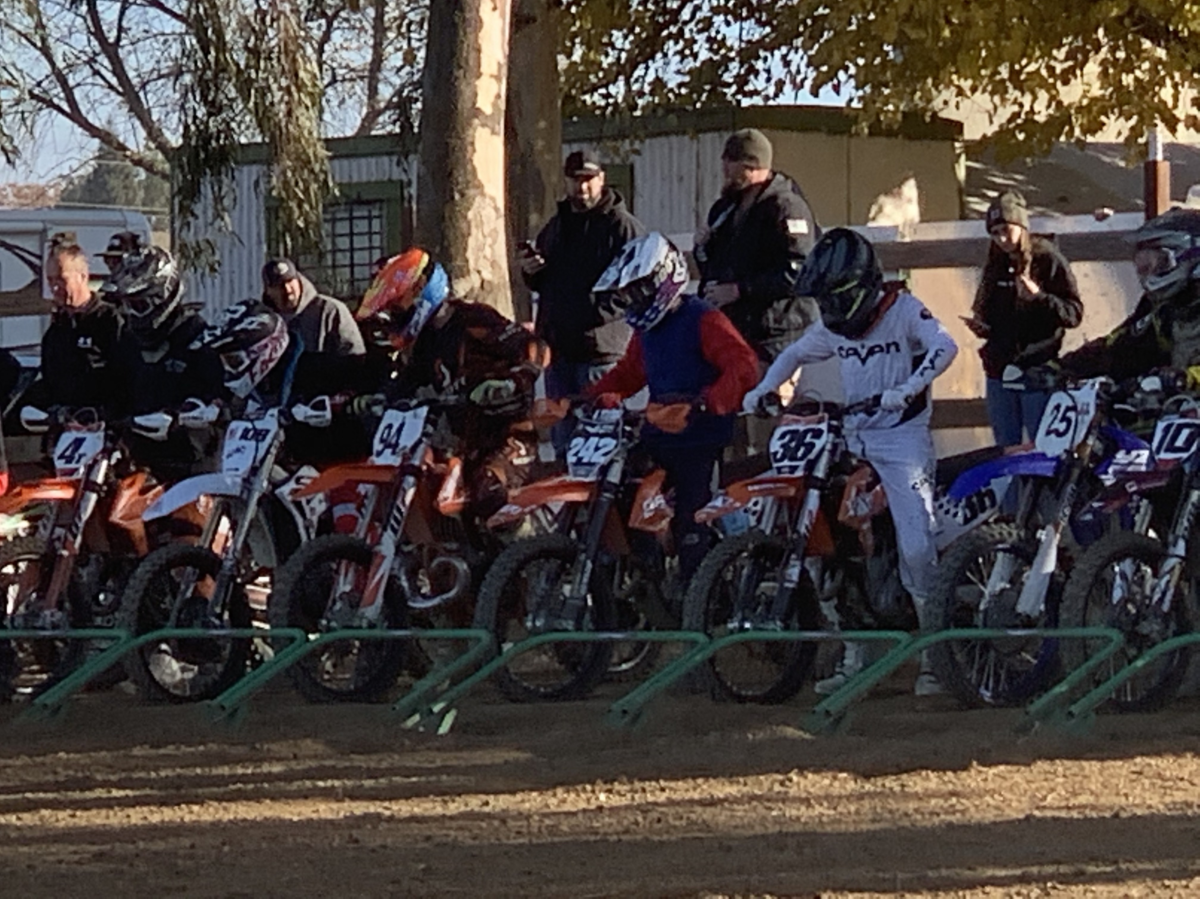 because my dad races off-road trucks in the Score International Off-Road Racing Series. When I’m not riding motorcycles, I am out playing Baseball.

SCHOOL

A few years ago, I was forced to leave Paradise California when our town burned down during the Camp Fire. We lost our home and nearly the whole town of Paradise, California. I now attend Corning High School in Corning California. I had to make new friends and find new extracurricular activities to participate in. After moving I really got serious about riding. I started entering races. Racing has become my whole life. I ride every opportunity possible. My favorite subject in school is P.E… (just kidding) it’s History and my least favorite subject is Math. My teachers say I am a pleasure to have in class. I have received awards in English as well. I know school is very important and if I don’t do well my Parents will not let me race.

EXPERIENCE

* 8/19 Final Round- Rep Racing Riverfront MX
* 9/19 Redding Dirt Riders Arena Cross
* 10/19 District 36 Mount Shasta Hard Enduro
* 11/19 Rep Racing Arena Cross Hang Town Mx
* 11/19 Motor Pro Triple Crown Argyle MX
* 7/11/20 Saturday night series #1
* 7/25/20 Saturday night series #2- 5th place
* 8/8/20 Saturday night series #3- 8th place
* 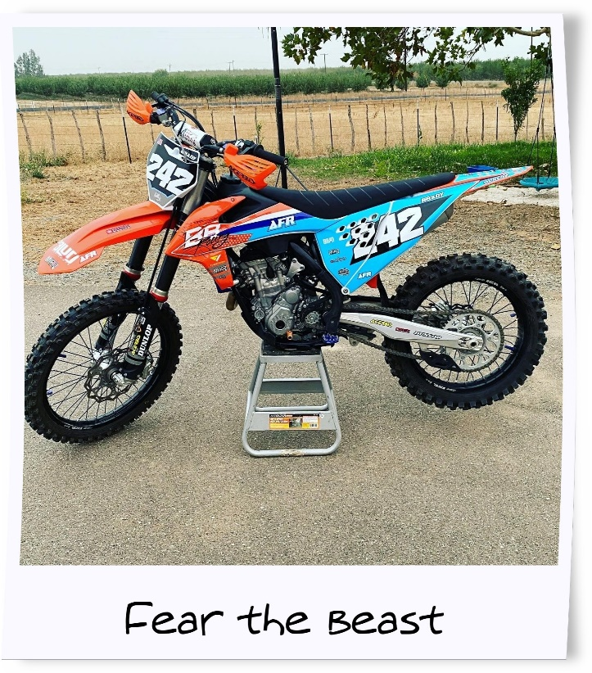8/22/20 Saturday night series #4- 10th place
* 9/05/20 Saturday night series #5- 10th place
* 10/04/20 Fall series #1 19/31
* 10/18/20 Fall series #2 19/31
* 11/01/20 Fall Series #3 13/31
* 11/15/20 Fall series #4 13/31
* 12/06/20 Fall series #5 14/29

Racing Expenses

Entry fees for the team- $150

Race entry fees- $40 per class. X2 =$80/ race day.

Race fuel- $10/ gallon. X10 = $80/ race day.

Box truck fuel- $100/ event

Food for the team- $200/ event

Other expenses include; oil, lubricants, tires, tubes, shocks, and shock tuning, plastics, graphics, wheels, sprockets, chains, tires, clutch and brake handles, handle bar grips, handle bars, tear offs, helmets, jerseys and pants, boots, and goggles.

What I can do for your company

I will always try to do my best and improve each race. I will always keep up with social media postings. When at practice or when racing I will always recommend people to your business. I will also wear your store apparel when I am able. When I’m on the Podium, I will thank my sponsors and give them the recognition they deserve. My main goal this season is to place in the top 3 in each of my races in the Rep Racing 250 C and 450 C classes. I will continue to work hard and improve. I WILL qualify for Loretta’s!